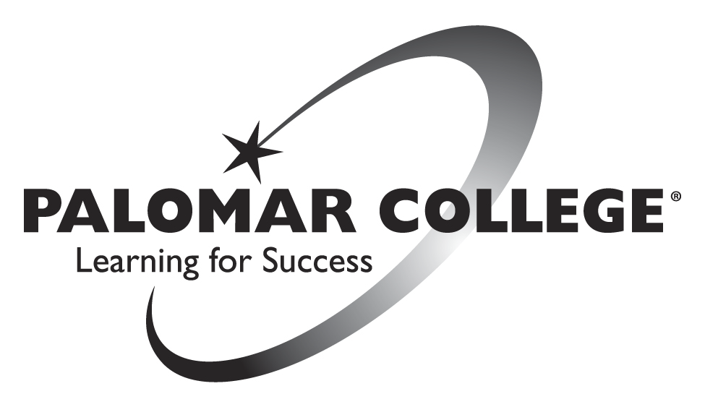
Nutrition Is The Vision
Minutes
October 15th, 2013
The meeting of the Nutrition Is the Vision Club was held on Tuesday, October 15th, 2013, in room MD-329 at Palomar College, San Marcos. The President greeted everyone and the meeting was called to order at 3:00 pm.

Roll Call

Members Present: Sarah Isabella, Michael Nagtalon, Xiaojing Ma (Lucy), Edward Penprase, Hannah Gross, Kevin Clukey, Laura Stanwick

Members absent: Daniel Arzola, Julio Valencia, Ken Cameron, Bianca Corado, Evan Davis, Sara Klapka, Maria Teresa Linares, Rebecca Enciso, Muoi Chan, Eddie Patino, Josh Smith, Liz Edmonston,

I. Minutes

The minutes from the October 8th, 2013 meeting has been approved unanimously.

II. Old Business

A. Events/projects in progress (2013)

The members of the club continued working on the “next step” to do for each event/project still in progress.
a. Guest Speaker(s) (Possible Candidates)
Karen Freeman, MS, RD, CSSD, Nutritionist Consultant;
b. Club Dinner(s)
Potluck
c. Community Garden / Garden at Palomar College
Start thinking about the top 5 most nutritious foods that you would like to plant. (fruits, veggies, herbs, medicinal, etc..)

B. Comet Celebration (October 14th and 15th 10:00 to 1:00pm SU Quad)

The president asked for a total of 4 volunteers for the upcoming Comet Celebration on October 14th and 15th between 10:00am to 1:00pm. Event theme will be “Eat this, not that”.

Volunteers for Monday, October 14th
Laura Stanwick
Michael Nagtalon (1130-100)
What did not go well;
keeping displays simply
having two people present
flyers were available to hand out
Signup sheet
Volunteers for Tuesday, October 15th
Edward Penprase
Laura Stanwick
Laura and Sarah volunteered to make visuals for displays

C. Palomar College Health Fair Event (October 21st 10:00 to 1:00pm
SU Quad)

The president asked for a total of 2 volunteers for the upcoming Comet Celebration event on October 21st between 10:00am to 1:00pm.

Volunteers for Monday, October 21st
Michael Nag talon (1000-100pm)
Laura Stanwick
Edward Penprase (900-1000pm)

D. Food for Food Event (November 6th, 2013 10:00am - 1:00pm at the SU Quad)

Bring $5 equivalence of non-perishable food or $5 dollars, and get back $5 equivalence of food.

E. Calorimeters

The nutrition club is starting to collect club members Basal Metabolic Rate (BMR), starting with members who have shown up to the meetings the most, and who has followed all pre-testing protocols. The advisor began calling members into here office one at a time.

F. Future goals and items for discussion
Mentorship Opportunity: If anybody is interested in a mentorship opportunity at the Boys and Girls Club, please contact Mike Nagtalon or Vanessa at the Boys and Girls Club, San Marcos.
2. Volunteer opportunity: If anybody would like to help volunteer with the gardens here on campus, please contact Edward Penprase or Tony Rangel (Supervisor for Grounds Services).

III. New business
none
IV. Other
Next Meeting:
Check up on Club Logo
V. Adjournment
The meeting was adjourned at 3:50 p.m.
Next meeting: October 22nd, 2013 at 3:00 p.m.

